Scenario
For the last year, you've been working as a junior cloud security analyst at Cymbal Retail. Cymbal Retail is a market powerhouse currently operating 170 physical stores and an online platform across 28 countries. They reported $15 billion in revenue in 2022, and currently employ 80,400 employees across the world.
Cymbal Retail boasts a vast customer base with a multitude of transactions happening daily on their online platform. The organization is committed to the safety and security of its customers, employees, and its assets, ensuring that its operations meet internal and external regulatory compliance expectations in all the countries it operates in.
Recently, the company has experienced a massive data breach. As a junior member of the security team, you’ll help support the security team through the lifecycle of this security incident. You'll begin by identifying the vulnerabilities related to the breach, isolate and contain the breach to prevent further unauthorized access, recover the compromised systems, remediate any outstanding compliance related issues, and verify compliance with frameworks.
Here’s how you'll do this task: First you’ll examine the vulnerabilities and findings in Google Cloud Security Command Center. Next, you’ll shut the old VM down, and create a new VM from a snapshot. Then, you’ll evoke public access to the storage bucket and switch to uniform bucket-level access control. Next, you’ll limit the firewall ports access and fix the firewall rules. Finally, you’ll run a report to verify the remediation of the vulnerabilities.

Analyst notes begin below:

-Logged on to Security Command Center at 0702 on January 16th, 2025 and took screenshot of overview

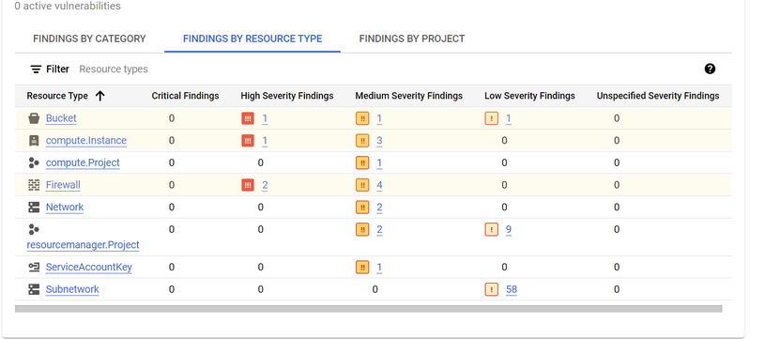
- High Severity Findings : Bucket(1), Compute Instance(1) and Firewall(2)

To further investigate went to the “Compliance Tab” of SCC .

As Cymbal bank must adhere to the PCI DSS compliance standard it would be used to asses vulnerabilities related to Bucket storage, Compute Instance and Firewall High Severity.

Findings of PCI Compliance Report
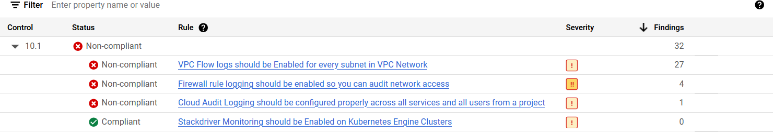
10.1 Non-Compliance

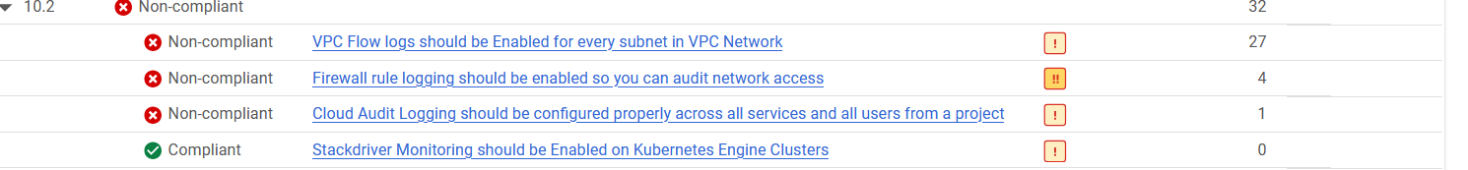
10.2 Non-Compliance

1.2.1 Non-Compliance
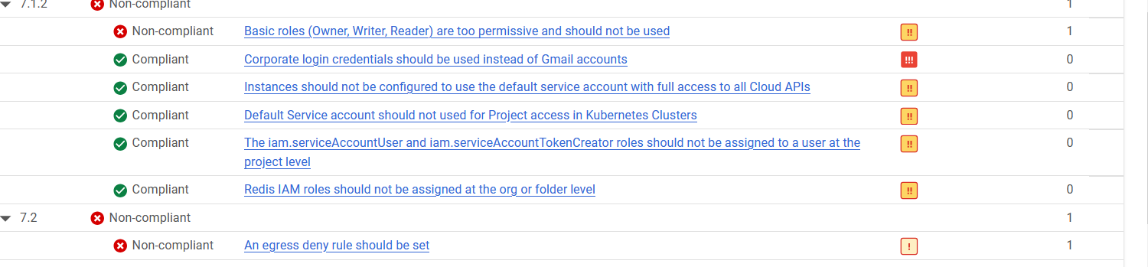
7.1.2 and 7.2 Non-Compliance

Findings from Google Cloud Storage Bucket Resource Type
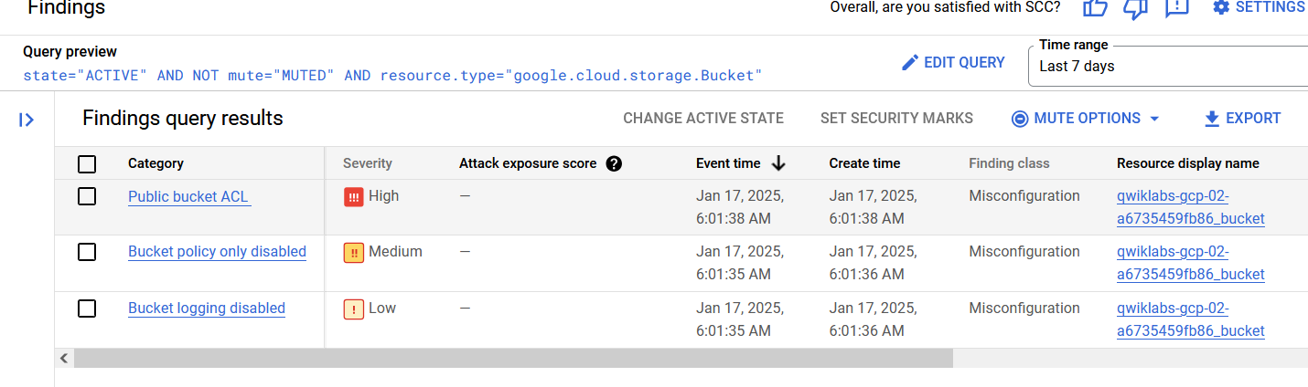
Evidence of Public Bucket ACL, Bucket Policy only disabled and Bucket Logging disabled issues

Findings from Google Compute Instance Resource Type
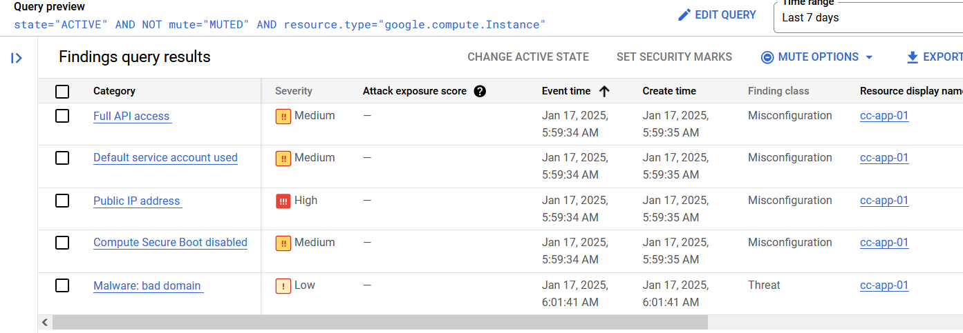
cc-app-01 issues

Findings from Google Firewall Resource Type

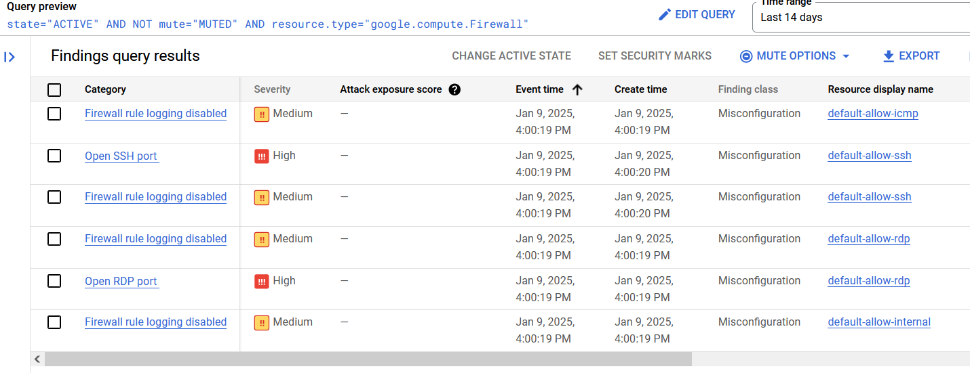
compute firewall issues from last 14 days

Summary of Primary Vulnerabilities

The most pressing vulnerabilities are the following:

- Public Bucket ACL(Storage)
- Public IP address(VM Instance)
- OpenSSH Port(Firewall)
- OpenRDP port(Firewall)

Resolution for Compute Resource(cc-app-01)

To remedy the vulnerabilities of cc-app-01, the VM will be shutdown and a new instance will be launched called cc-app-02 from the last good backup of cc-app-01 with appropriate security controls for access. The correct service account will be recognized by adding network tags “cc” we can later fine tune access when updating firewall rules.

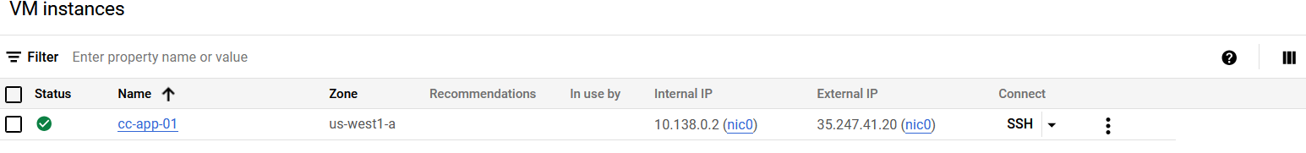
Vulnerable app running

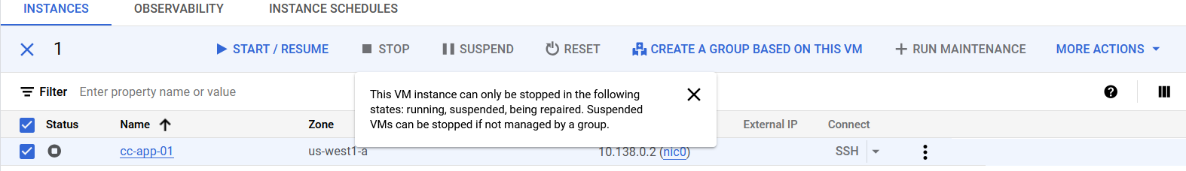
Application stopped

Creating new VM(cc-app-02)

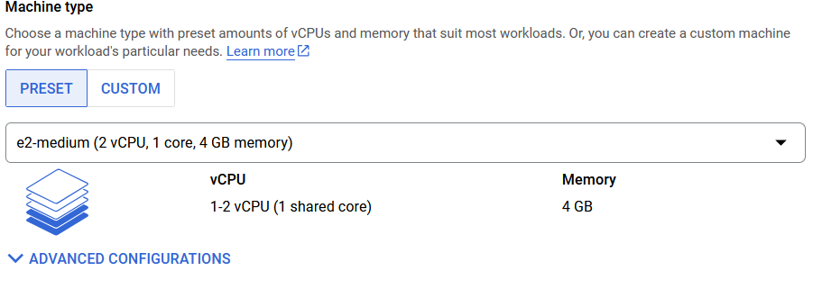
Machine type of cc-app-02

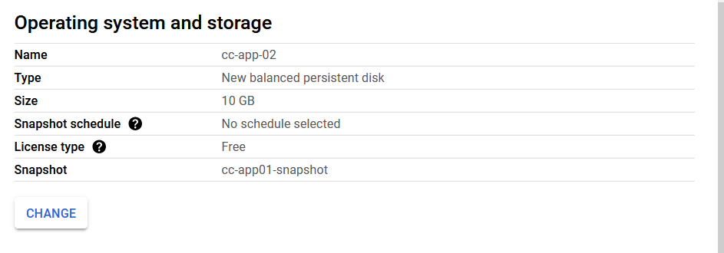
cc-app-02 imaged from snapshot of cc-app-01

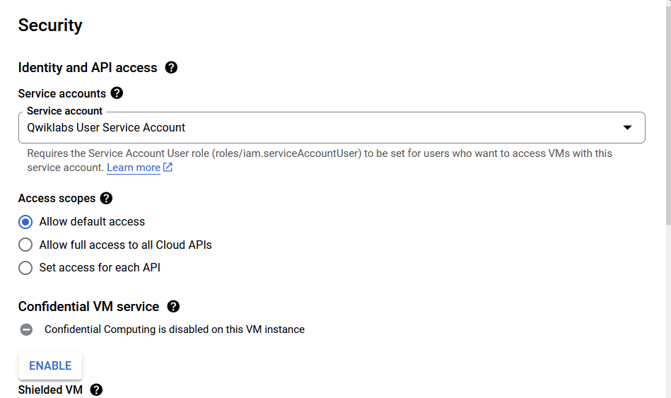
cc-app-02 using correct IAM service account

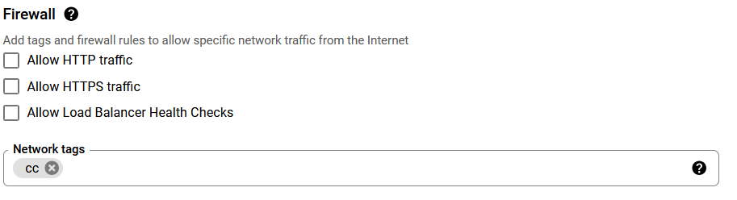
used the “cc” network tag for future firewall rules

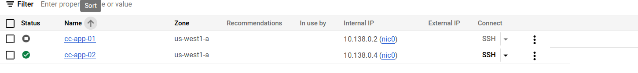
cc-app-02 successfully created, secure boot enabled after reboot(not shown in report)

Cloud Bucket Storage Resolution

Within the cloud storage bucket the permissions have not been properly set as Public Access has been enabled. To resolve this issue, the Public Internet Access permissions were removed under the “Permissions Tab”. Further, access controls were set from “fine grained” to “uniform. In order to order not to impact original user the option (“Add project role ACLs to the bucket IAM
policy”) was selected before applying the changes.
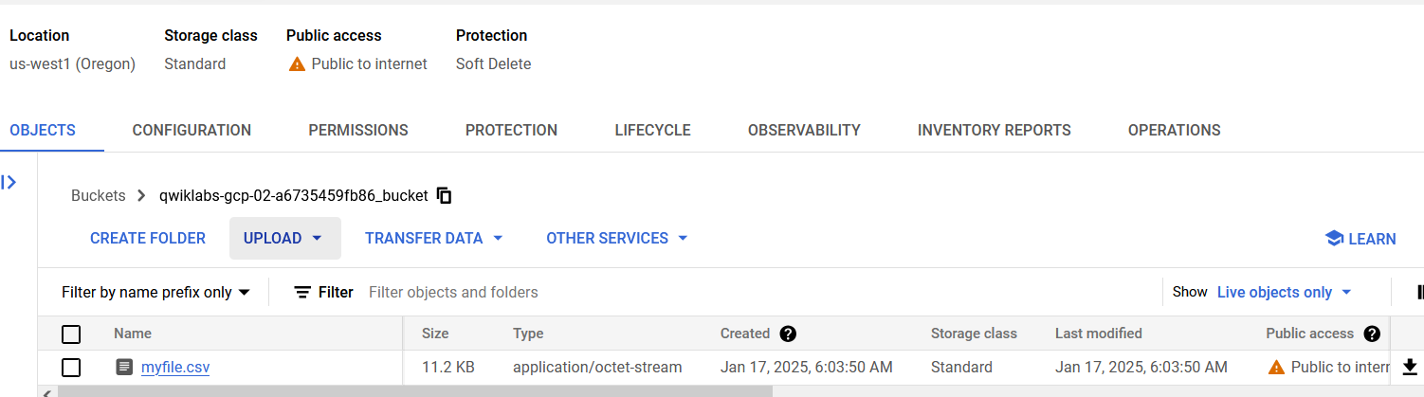
Storage Bucket Permissions currently vulnerable

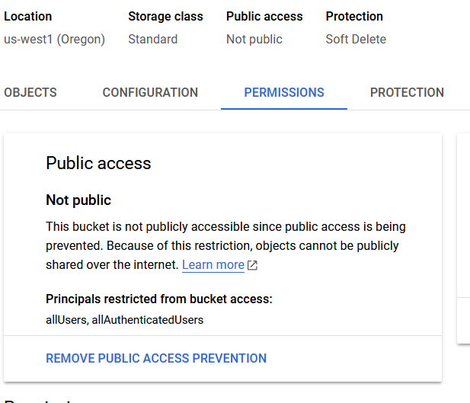
Publice access removed from bucket

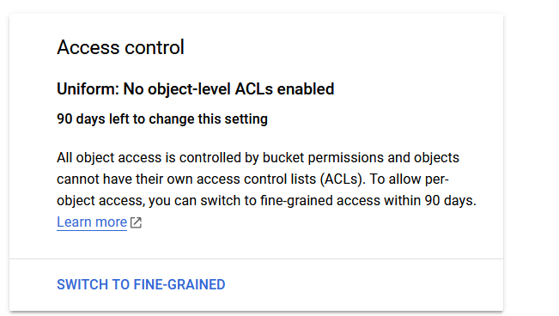
Uniform access control enabled(note allUsers legacy permissions removed but not shown in report)

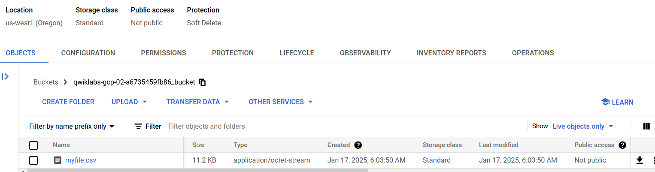
Storage Bucket no longer public

Firewall Resource Resolution

The rules “default-allow-icmp”, “default-allow-rdp” and “default-allow-ssh” are to overly broad and allow access from all inbound network connections. To remedy this issue, a strict SSH rule to a range of acceptable IP ranges was created to look for the “cc” network tag to harden access to cc-app-02. The overly broad rules were deleted leaving only the “restrict-ssh-rule’ and “default-allow-internal” rules. Logging enabled on the last rules for monitoring.

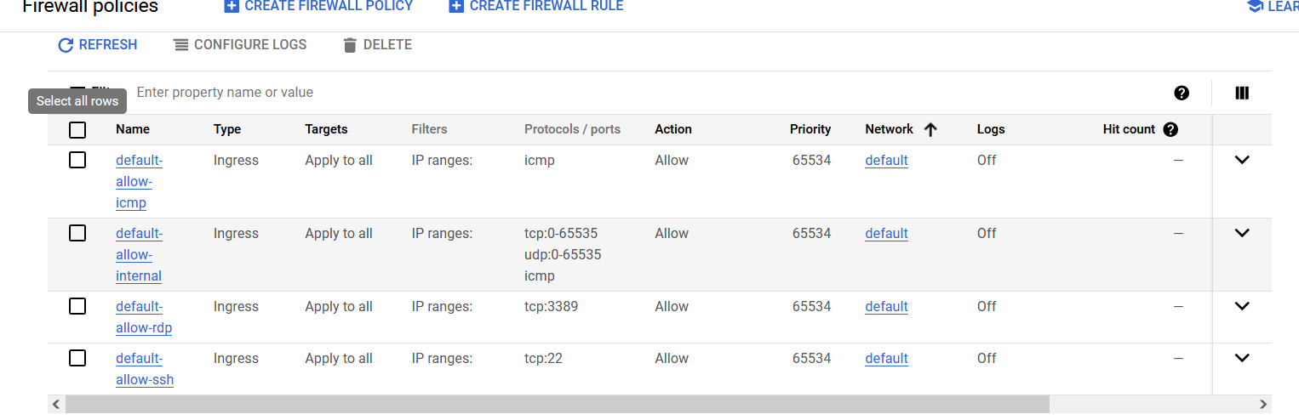
Vulnerable SSH and RDP

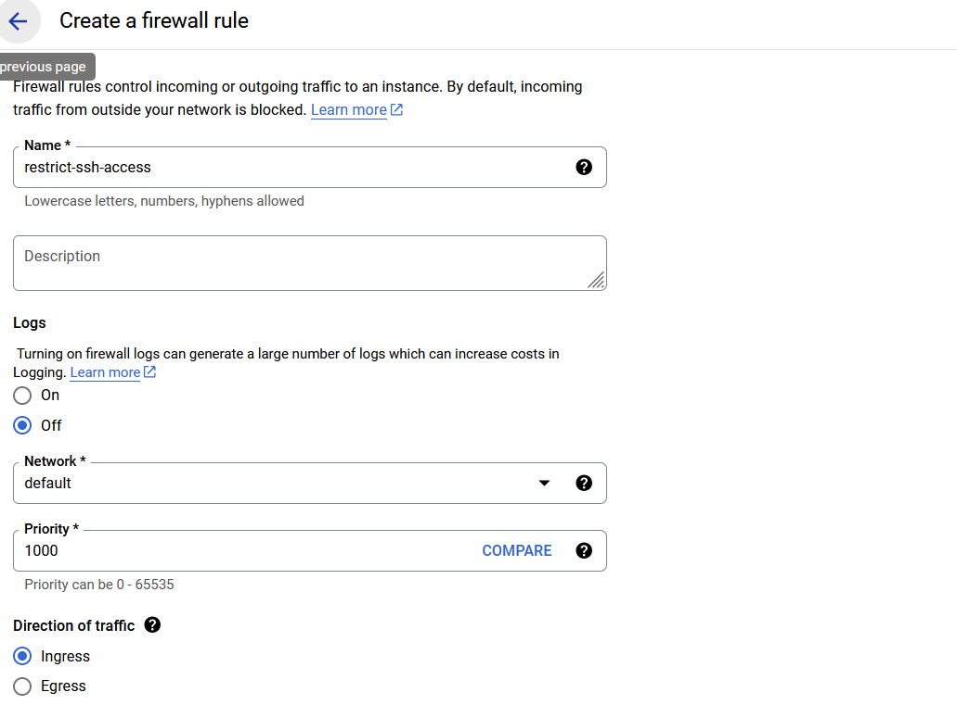
Rule “restrict-ssh-access” created, network tags and source IP ranged in next screenshot

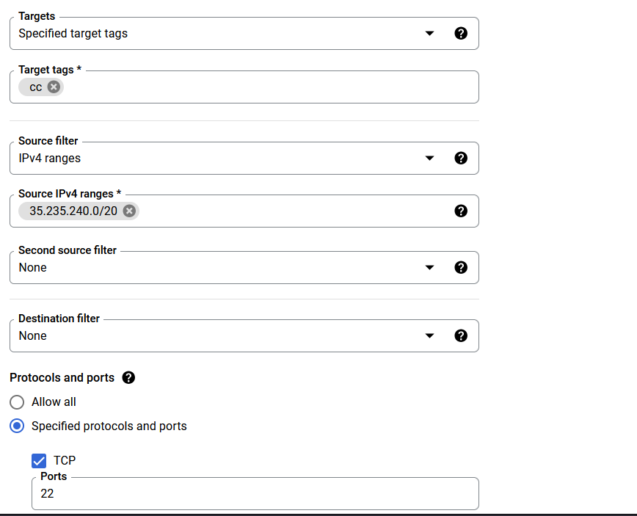
SSH only on 32.253.240.0/20 with “cc” network tags

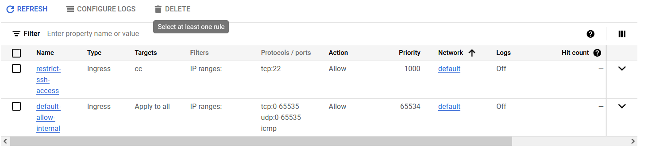
Deleted ICMP, OpenSSH and OpenRDP vulnerabilities

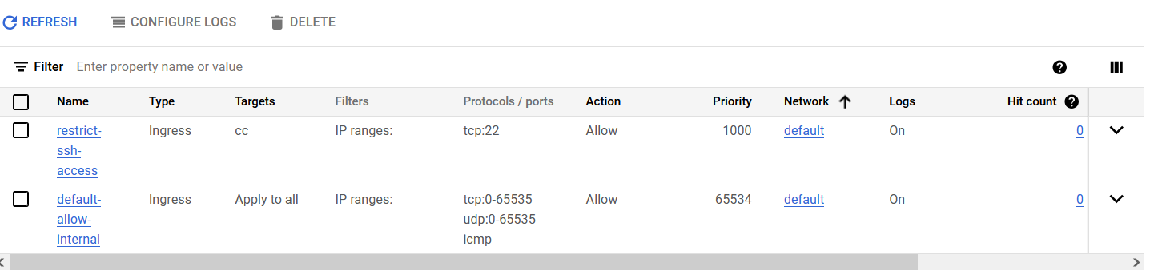
Logging Enabled

